In using this application, the user should be able to achieve the following:

* **Add** a new record and the application to display a message if that record will be a duplicate
* **Delete** any record selected
* **Update** an existing record and not allow empty input fields
* **Print** all records in the table i.e. write out the records to a text file
* **Cancel** changes done to the currently displaying record and display the record in its previous state before the changes were done to it.
* **Exit** the application at any point during the execution of the application.

**Add button:** On clicking the add button, all input areas will be validated checking if all have values before the new record is written to the table. The Primary key value will be checked as the values allowed a from 200 – 1000 (inclusive). If the value entered is not within this specified range, the following dialog window will display.

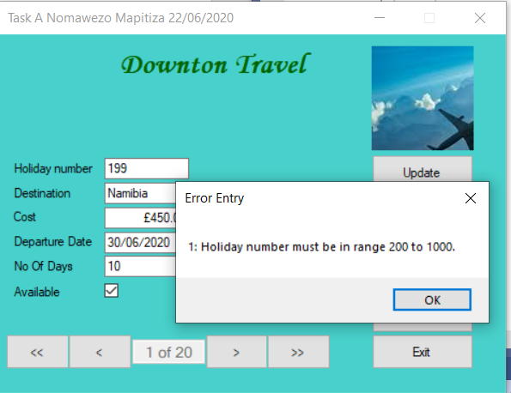

After clicking the OK button, the cursor will be sitting on the input field whose validation triggered the message.

If adding the new record will cause a duplication of the record in the table i.e. the “Holiday number” already exist, the following dialog window will display with a message.

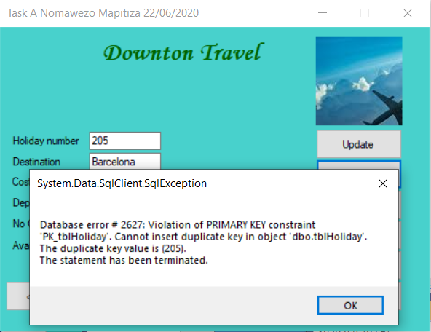

When the OK button is clicked, the process will allow for the correct “Holiday number” to be entered and the new record should be written out to the table.

If there is no value entered for the “Holiday number” and an Add button is clicked, the process will not continue until the right value is entered.

**Update button:** The application allows for all the input fields to be edited. When the update button is clicked, if changes were made to the “Holiday number”, the application process would not allow the update until same Holiday number before the changes is written. The update will be done if any of the input fields value has been changed.

**Delete button:** On clicking the delete button, the current displaying record will be removed from the screen and will also be deleted from the table and the previous record will be displayed.

**Print button:** On clicking the print button, all records in the table will be written out to a text file. If the check box was checked, the record will be written to the text file with a “Yes” under the Available column and a “No” if it was not checked.

**Cancel button:** If any changes were made to the current displaying record and the cancel button is clicked, the record displayed before the changes were made will be displayed. All changes will be erased. If the Exit button is clicked after the changes were done but not updated, the execution of the application will be terminated, and the changes will not be saved.

**Exit button:** On clicking the exit button, the execution of the application will be terminated immediately.

**Navigator bar:**

* When the button with the caption **<<** is clicked, the first record in the table will be displayed.
* When the button with the caption **<** is clicked, the previous record in the table will be displayed.
* When the button with the caption **>** is clicked, the next record in the table will be displayed
* When the button with the caption **>>** is clicked, the last record in the table will be displayed.